pITZA SALES ANALYSIS

**Problem statement**-Analyze key indicators for our pizza sales data to gain insight into our business performance.

**Tool Used**- **SQL, PowerBI, Excel**

**KPI’s Requirement –**

* **TOTAL REVENUE**-Sum of total price of all pizza orders

SELECT SUM(total_price) AS Total_Revenue from pizza_sales;

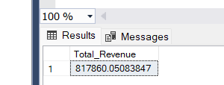

* **AVERAGE ORDER VALUE**-Average amount spent per order calculated by dividing total revenue divided by total number of orders.

SELECT (SUM(total_price) / COUNT(DISTINCT order_id)) AS AVERAGE_ORDER_VALUE FROM pizza_sales;

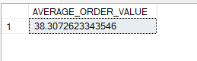

* **TOTAL PIZZA SOLD**-The sum of quantities of all the pizzas

SELECT SUM(quantity) AS TOTAL_PIZZAS_SOLD FROM pizza_sales

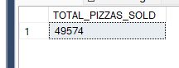

* **TOTAL ORDERS-**the total numbers of orders placed

SELECT COUNT(DISTINCT order_id) FROM pizza_sales;

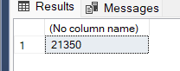

* **AVERAGE PIZZAS PER ORDER-**the average number of pizzas sold per order

SELECT CAST(CAST(SUM(quantity) AS DECIMAL (10,2))/ CAST(COUNT(DISTINCT order_id) AS DECIMAL (10,2))AS DECIMAL (10,2)) AS AVERAGE_PIZZAS_PER_ORDER FROM pizza_sales;

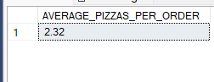

problem statement

CHART REQUIREMENT

We would like to visualize various aspects of our pizza sales data to gain insights and understand key trend. We have identified the following requirement for creating charts

* **DAILY TREND FOR TOTAL ORDER-**create a bar chart that displays the daily trend of total orders over a specific time period. This chart will help us to identify any pattern or fluctuation in order volume on a daily basis

SELECT DATENAME(DW,order_date) AS ORDER_DAY,COUNT(DISTINCT order_id) AS TOTAL_NUMBER_ORDER FROM pizza_sales

GROUP BY DATENAME(DW,order_date)

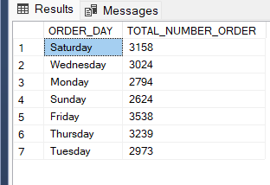

* **MONTHLY TREND FOR TOTAL ORDER** – create a bar chart that displays the monthly trend of total orders over a specific time period. This chart will help us to identify any pattern or fluctuation in order volume on a monthly basis

SELECT DATENAME(MONTH,order_date) AS ORDER_MONTH,COUNT(DISTINCT order_id) AS TOTAL_NUMBER_ORDER FROM pizza_sales

GROUP BY DATENAME(MONTH,order_date)

ORDER BY DATENAME(MONTH,order_date) ASC

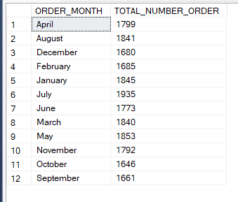

* **HOURLY TREND FOR TOTAL ORDER**-Create a line chart that illustrates the hourly trend of total orders throughout the day. This chart will allow us to identify peak hours or period of high order activity
* **F SALES BY PIZZA CATEGORY**-create a pie chart that shows the distribution of sales across different pizza category. This chart will provide insight into the popularity of various pizza category and their contribution to overall sale.

SELECT pizza_category ,CAST(sum(total_price)*100 / (SELECT sum(total_price) FROM pizza_sales) AS DECIMAL (10,2)) AS CATEGORY_WISE_PERCENTAGE

FROM pizza_sales

GROUP BY pizza_category;

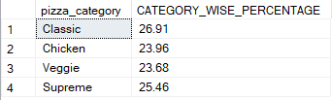

* **PERCENTAGE SALES BY PIZZA SIZE**-GENERATE a pie chart that represents the percentage of sales attributed to different pizza sales. This chart will help us understand customer preference for pizza sizes and their impact on sales

SELECT pizza_size ,CAST(sum(total_price)*100 / (SELECT sum(total_price) FROM pizza_sales) AS DECIMAL (10,2)) AS PIZZA_SIZE_WISE_PERCENTAGE

FROM pizza_sales

GROUP BY pizza_size;

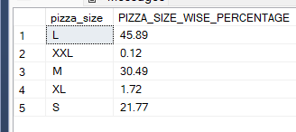

* **TOTAL PIZZAS SOLD BY PIZZA CATEGORY**-create a funnel chart that represent the total number of pizzas sold for each pizza category. This chart will allow us to compare the sales performance of different pizza category.

SELECT pizza_category,COUNT(quantity) AS TOTAL_PIZZA_SOLD_CATEGORY

FROM pizza_sales

GROUP BY pizza_category

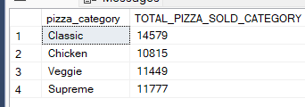

* **TOP 5 BEST SELLER PIZZA BY REVENUE-**

SELECT TOP 5 pizza_name, CAST(SUM(total_price) AS DECIMAL (10,2)) AS TOTAL_REVENUE

FROM pizza_sales

GROUP BY pizza_name

ORDER BY TOTAL_REVENUE DESC

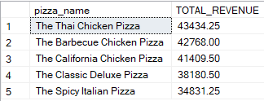

* **BOTTOM 5 BEST SELLER PIZZA BY REVENUE-**

SELECT TOP 5 pizza_name, CAST(SUM(total_price) AS DECIMAL (10,2)) AS TOTAL_REVENUE

FROM pizza_sales

GROUP BY pizza_name

ORDER BY TOTAL_REVENUE ASC

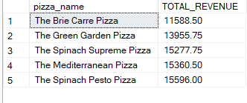

* **TOP 5 BEST SELLER PIZZA BY QUANTITY-**

SELECT TOP 5 pizza_name, SUM(quantity) AS TOP_5_PIZZA_QUANTITY

FROM pizza_sales

GROUP BY pizza_name

ORDER BY TOP_5_PIZZA_QUANTITY DESC

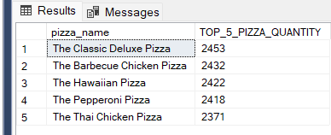

* **BOTTOM 5 BEST SELLER PIZZA BY QUANTITY-**

SELECT TOP 5 pizza_name, SUM(quantity) AS BOTTOM_5_PIZZA_QUANTITY

FROM pizza_sales

GROUP BY pizza_name

ORDER BY BOTTOM_5_PIZZA_QUANTITY ASC

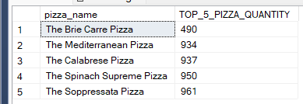

* **TOP 5 BEST SELLER PIZZA BY ORDER-**

SELECT TOP 5 pizza_name, COUNT(DISTINCT order_id) AS TOP_5_PIZZA_ORDERS

FROM pizza_sales

GROUP BY pizza_name

ORDER BY TOP_5_PIZZA_ORDERS DESC

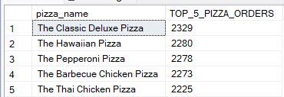

* **BOTTOM 5 BEST SELLER PIZZA BY ORDER-**

SELECT TOP 5 pizza_name, COUNT(DISTINCT order_id) AS BOTTOM_5_PIZZA_ORDERS

FROM pizza_sales

GROUP BY pizza_name

ORDER BY BOTTOM_5_PIZZA_ORDERS ASC

